**PIZZA SALES SQL QUERIES**

**A.KPI’s.**

**1. Total Revenue:**

SELECT SUM(total_price) AS Total_Revenue FROM pizza_sales

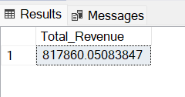

**2. Average Order Value:**

SELECT (SUM(total_price)/COUNT(DISTINCT order_id)) as Avg_Order_Value FROM pizza_sales

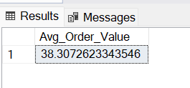

**3. Total Pizzas Sold:**

SELECT SUM(quantity) as Total_Pizza_Sold FROM pizza_sales

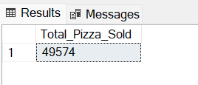

**4.Total Orders:**

SELECT COUNT(DISTINCT order_id) as Total_Order FROM pizza_sales

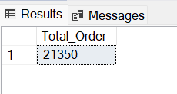

**5.Average pizza per order:**

SELECT CAST(CAST(SUM(quantity) as decimal(10,2)) / CAST(COUNT(DISTINCT order_id) as decimal(10,2)) as decimal (10,2))

as Avg_pizza_per_order FROM pizza_sales

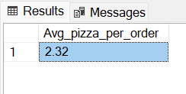

**B. Daily Trend for Total Orders**

SELECT DATENAME(dw, order_date) as Order_day, COUNT(DISTINCT order_id) as Total_order

FROM pizza_sales

GROUP BY DATENAME(dw, order_date)

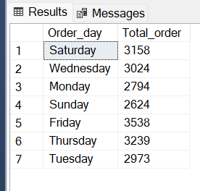

**C. Monthly Trend for Orders**

SELECT DATENAME(MONTH, order_date) AS order_month, COUNT(DISTINCT order_id) as Total_order

FROM pizza_sales

GROUP BY DATENAME(MONTH, order_date)

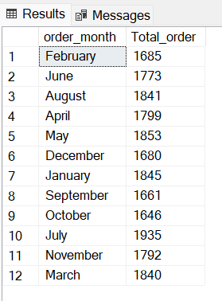

**D. % of Sales by Pizza Category**

SELECT pizza_category, SUM(total_price) * 100 / (SELECT SUM(total_price) FROM pizza_sales) as PCT

FROM pizza_sales GROUP BY pizza_category

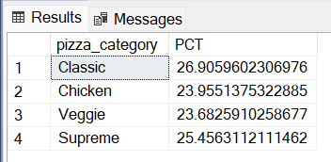

**E. % of Sales by Pizza Size**

SELECT pizza_size, SUM(total_price) AS revenue, SUM(total_price) * 100 / (SELECT SUM(total_price) FROM pizza_sales) AS PCT

FROM pizza_sales GROUP BY pizza_size

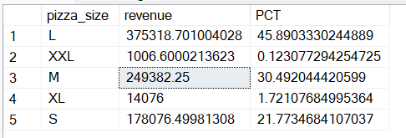

**F. Total Pizzas Sold by Pizza Category**

SELECT pizza_category, SUM(quantity) as Total_Quantity_Sold FROM pizza_sales

GROUP BY pizza_category

ORDER BY Total_Quantity_Sold DESC

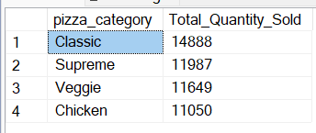

**G. Top 5 Pizzas by Revenue**

SELECT TOP 5 pizza_name, SUM(total_price) AS Revenue FROM pizza_sales

GROUP BY pizza_name

ORDER BY Revenue DESC

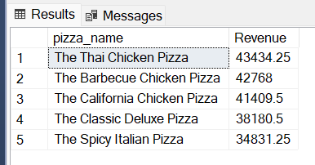

**H. Bottom 5 Pizzas by Revenue**

SELECT TOP 5 pizza_name, SUM(total_price) AS Revenue FROM pizza_sales

GROUP BY pizza_name

ORDER BY Revenue ASC

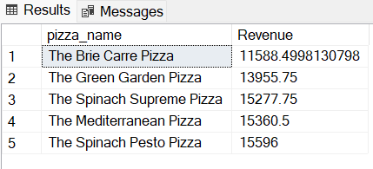

**I. Top 5 Pizzas by Quantity**

SELECT TOP 5 pizza_name, SUM(quantity) as Total_pizza_sold FROM pizza_sales

GROUP BY pizza_name

ORDER BY Total_pizza_sold DESC

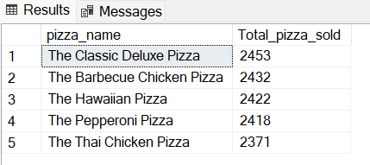

**J. Bottom 5 Pizzas by Quantity**

SELECT TOP 5 pizza_name, SUM(quantity) as Total_pizza_sold FROM pizza_sales

GROUP BY pizza_name

ORDER BY Total_pizza_sold ASC

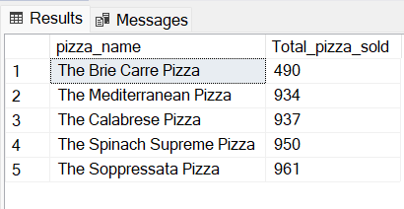

**K. Top 5 Pizzas by Total Orders**

SELECT TOP 5 pizza_name, COUNT(DISTINCT order_id) as Total_pizza_order FROM pizza_sales

GROUP BY pizza_name

ORDER BY Total_pizza_order DESC

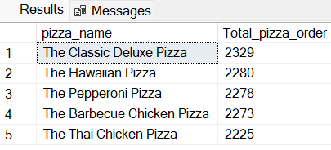

**L. Borrom 5 Pizzas by Total Orders**

SELECT TOP 5 pizza_name, COUNT(DISTINCT order_id) as Total_pizza_order FROM pizza_sales

GROUP BY pizza_name

ORDER BY Total_pizza_order ASC

